

**MASENO UNIVERSITY**

**SCHOOL OF COMPUTING AND INFOMATICS**

**DEPATMENT OF COMPUTER SCIENCE**

**CCS 403: PROJECT 1**

# **PROJECT TITLE**

SMART FARM

**NAME** **REGISTRATION**

* ANIDA KIMTAI KIRUI CCS/00012/020

A project report submitted in partial fulfillment of the requirement for the Bachelor of Science Degree (BSc.) in Computer Science

# **DECLARATION**

I the undersigned do hereby declare that the report of the project titled Smart Farm It is based on my own investigations based on information from sources that stated. I also declare that the work was never produced by any student from the school of computing (computer science) and to the best of my knowledge it has not been presented to any other examination body

Declaration signature;

Name: ..................................................

Signature: .............................................

Date: ....................................................

This project report is hereby presented for examination with the approval of the project supervisor.

* Name: ......................................................... Signature: ............................

Date: .....................................

# **DEDICATION**

Thanks to Allah, the most Merciful and the most Gracious. Special thanks to My supervisor, Dr James Obuhuma for his professional guidance and support in academic and in real life. I’m greatly indebted for his patience and invaluable advices that inspired me to see things positively and felt honoured with his confidence and trust on my own ability. Last but not least, not forgetting those who have directly or indirectly helped me on this thesis. May Allah rewards your kindness in abundance in this world and next.

# **Acknowledgement**

It is always a great relief when you done with something you have been working on for a long time. It is the same when you complete your final project. Unlike other assignment, a project is successfully completed with the mental moral guidance of your mentor, friends, course mates, family and generally the whole school department.

I would like to express me special thanks to my mentor and guide through the start of the project Dr James Obuhuma for his time, effort and dedication in providing me with the right and most appreciated guideline in all effort to ensure i have a smooth and easy task in doing this project. Your useful advice was really helpful to us during the project completion. In this aspect, I am eternally grateful to you.

More and more special thanks to the school of computing (computer science) department for all the help they have provide either directly or indirectly. Special thanks to our school dean and the head of our department for the provision of the school WI FI and our helpful lecturers they have been helpful throughout. I take this chance to eternally thank you and all the department staff for all their help. I say “Shukran Dr”.

# **Abstract**

In an era characterized by the transformative power of technology, the agricultural sector stands at the forefront of innovation. The "Smart Farm" project is a visionary initiative that leverages cutting-edge technology to redefine farming practices. Comprising five key modules, this integrated system enhances water management, irrigation, livestock care, cold storage, and feeding operations. Seamlessly unified through a user-friendly mobile application, the "Smart Farm" project not only optimizes efficiency but also empowers farmers with remote control and real-time data access, revolutionizing the way farming is conducted. With a focus on sustainability, resource optimization, and improved crop and livestock care, this project paves the way for a more productive and eco-conscious agricultural future.

Embracing the digital age, the "Smart Farm" project represents a pioneering solution that addresses contemporary challenges in agriculture. By introducing automation and remote accessibility, it streamlines farming operations, reduces waste, and ensures the well-being of both crops and livestock. As urbanization continues to reshape landscapes, this project offers a timely response to the evolving needs of the farming community. Through its innovative approach, the "Smart Farm" project not only promises to increase agricultural productivity but also empowers farmers to thrive in an ever-changing world, marking a significant step towards sustainable and efficient farming practices.

Contents

**PROJECT TITLE** i

**DECLARATION** ii

**DEDICATION** iii

**Acknowledgement** iv

**Abstract** v

**LIST OF TABLES** viii

Below are tables in the project: viii

**LIST OF FIGURES** ix

Below is list of figures in the project: ix

**LIST OF TERMS** x

**CHAPTER 1: INTRODUCTION** 1

**1.1 Statement of the research problem** 1

**1.2 Statement of the problem.** 1

**1.3 How to solve the problem?** 2

**1.4 Purpose of the study** 2

**1.5 Justification** 2

**1.6 Research Questions** 4

1.7 Project scope 4

1.8 Limitation of the system 5

**CHAPTER 2: SYSTEM ANALYSIS** 5

2.1 Introduction 5

2.2 The Systems Development Methodology that is used in the research. 6

2.3 Feasibility Study. 6

2.4 Requirements elicitation: 7

2.5 Data and System Analysis: 8

2.6 User requirements 8

2.7 Non-functional requirements 9

2.8 System Specification Outline the systems requirements 9

2.9 What the application will do: 11

**CHAPTER 3: SYSTEM DESIGN** 12

3.1 Specify logical design and physical design. 12

3.2 System Architecture 13

3.2 Object Models using activity diagrams 19

❖ Registration Form 19

❖ Vendor login Form 20

❖ Membership Application Form 21

❖ House upload Form 22

❖ Customer Booking Form 23

❖ Admin Login Form 25

3.3 Database design for the system. 28

**CHAPTER 4: CONCLUSIONS AND RECOMMENDATIONS** 29

5.1CONCLUSIONS: 29

# **LIST OF TABLES**

## Below are tables in the project:

# **LIST OF FIGURES**

## Below is list of figures in the project:

# **LIST OF TERMS**

# **CHAPTER 1: INTRODUCTION**

## **1.1 Statement of the research problem**

The modern agricultural landscape is confronted with a myriad of challenges, including fluctuating water resources, unpredictable weather patterns, and the growing demand for sustainable practices. Traditional farming methods often struggle to cope with these complexities, leading to inefficiencies, resource wastage, and compromised crop and livestock care. In this context, the research problem at the heart of this study is to address these challenges and inefficiencies by developing a comprehensive and technologically advanced "Smart Farm" solution. This solution aims to optimize water management, irrigation practices, livestock health, cold storage, and feeding processes while ensuring remote accessibility and control for farm management. By addressing these pressing issues, the research seeks to usher in a new era of precision and efficiency in agriculture, fostering sustainability and resilience in the face of an evolving agricultural landscape.

## **1.2 Statement of the problem.**

*Why is it a problem?*

The problem lies in the inefficiencies of traditional farming practices, including inadequate water management, irrigation, livestock care, cold storage, and feeding methods. These shortcomings hinder agricultural productivity, sustainability, and profitability. Addressing these issues through the "Smart Farm" project is crucial to modernize agriculture and ensure efficient, sustainable practices.

## **1.3 How to solve the problem?**

To solve these challenges, we propose the development of an integrated "Smart Farm" system. Leveraging sensors, automation, and a user-friendly mobile app, this solution optimizes water usage, irrigation, livestock care, cold storage, and feeding. It centralizes data, allowing remote monitoring and control, promoting precision, efficiency, and sustainability in agriculture.

## **1.4 Purpose of the study**

The impact of such ideas will greatly improve house renting and selling. In this case the economy will greatly achieved as compare to previous where by majority of the salesman depend on manual activities.

**Objectives**

* To develop an integrated "Smart Farm" system to address agricultural inefficiencies.
* To optimize water management, irrigation, livestock care, cold storage, and feeding processes.
* To centralize data and provide remote monitoring and control via a user-friendly mobile app.
* To enhance precision, efficiency, and sustainability in agriculture.
* To contribute to the advancement of modern farming practices and food security.

## **1.5 Justification**

* Enhanced Agricultural Efficiency: The "Smart Farm" system promises to significantly improve the efficiency of farming operations, leading to increased productivity and reduced resource wastage.
* Sustainability: By optimizing water use, reducing waste, and promoting eco-conscious practices, this study aligns with the global push for sustainable agriculture.
* Food Security: Improved crop and livestock care contribute to increased food production, addressing the ongoing challenge of food security.
* Technological Advancement: Embracing technology in agriculture ensures that the industry remains relevant and competitive in the modern era.
* Economic Benefits: Streamlining farm operations can lead to increased profitability for farmers, making agriculture a more attractive and sustainable livelihood.
* Environmental Impact: Efficient resource management reduces the environmental footprint of farming practices, benefiting both local ecosystems and global sustainability goals.
* Accessibility: Remote monitoring and control empower farmers with greater accessibility and ease in managing their farms, enhancing their quality of life.
* Innovation: This study fosters innovation in agriculture, contributing to the ongoing evolution of the industry.

## **1.6 Research Questions**

* How can the "Smart Farm" system effectively optimize water management in agricultural practices?
* In what ways can the "Smart Farm" system improve the efficiency of irrigation processes while conserving resources?
* How can the "Smart Farm" system enhance livestock care and hygiene through automation and technology?
* In what manner can the system maintain precise temperature conditions in cold storage, reducing food spoilage and waste?
* How will the "Smart Farm" system automate feeding processes to ensure timely and efficient care for livestock?
* What are the impacts of remote monitoring and control through a mobile application on farm management and sustainability?

Significance of the study

This study holds significant importance as it addresses pressing agricultural challenges while enhancing efficiency and promoting sustainability. By improving water management, irrigation, livestock care, cold storage, and feeding processes, it contributes to increased food production and reduced resource wastage. This research aligns with global sustainability goals, fostering the modernization of farming practices and enabling a more resilient, eco-conscious agricultural sector. Additionally, it grants remote access, providing farmers with convenient control over their operations, paving the way for a future where agriculture thrives amidst evolving demands and environmental considerations.

## 1.7 Project scope

The project scope encompasses the development and implementation of the "Smart Farm" system, focusing on optimizing water management, irrigation, livestock care, cold storage, and feeding processes. It also includes the integration of remote monitoring through a user-friendly mobile application. The study primarily targets improving agricultural efficiency and sustainability

## 1.8 Limitation of the system

System limitations include potential technical glitches, dependence on network connectivity for remote control, and the initial cost of installation. Compatibility issues with older farming infrastructure and the need for training may also pose challenges. Additionally, the system may not address all unique farm-specific requirements.

# **CHAPTER 2: SYSTEM ANALYSIS**

## 2.1 Introduction

The system analysis phase is a critical stage in the development of the "Smart Farm" project. It involves a comprehensive examination of the current agricultural practices, technology integration requirements, and stakeholder needs. This phase aims to identify key objectives, constraints, and opportunities for system enhancement. By analysing the existing agricultural landscape and evaluating the potential benefits and challenges of the proposed "Smart Farm" system, we lay the foundation for its successful design and implementation, ultimately revolutionizing the way farming is conducted.

## 2.2 The Systems Development Methodology that is used in the research.

Methodology is will be:

The research employs an iterative and incremental systems development methodology, drawing inspiration from Agile practices. This approach allows for flexibility and adaptability in response to evolving project requirements and stakeholder feedback. It promotes collaboration, prioritization, and rapid prototyping to ensure the "Smart Farm" system aligns effectively with user needs and evolving agricultural dynamics.

## Feasibility Study.

* Technical Feasibility:

Purpose: To assess the practicality of implementing the proposed technology.

Key Considerations: It evaluates whether the required hardware, software, technical expertise, and infrastructure are available or can be obtained within the project's constraints.

Outcome: This study determines if the technology can be developed or integrated effectively for the project.

* Economic Feasibility:

Purpose: To determine if the project is financially viable.

Key Considerations: It involves conducting a cost-benefit analysis, assessing return on investment (ROI), and examining the budget to understand whether the project can generate enough revenue to cover costs.

Outcome: Economic feasibility study establishes if the project is economically justifiable and financially sustainable.

* Operational Feasibility:

Purpose: To assess how well the project aligns with existing organizational operations and processes.

Key Considerations: This study examines the current workflow, systems, and the readiness of the staff to determine if the project can be smoothly integrated into the organization's operations.

Outcome: Operational feasibility determines if the project will disrupt existing processes and whether adjustments are needed.

* Schedule Feasibility:

Purpose: To analyze if the project can be completed within the required timeframe.

Key Considerations: This involves creating a project timeline, setting milestones, and assessing the availability of necessary resources to ensure that the project can meet deadlines.

Outcome: Schedule feasibility study ensures that the project can be executed according to the specified timeline and time constraints.

## 2.4 Requirements elicitation:

Requirements elicitation for the "Smart Farm" will be gathering and documenting specific project requirements related to optimizing water management, irrigation, livestock care, cold storage, and feeding processes in agricultural operations. It involves engaging with stakeholders to define the system's scope, functionalities, and performance criteria, ensuring that the system aligns effectively with the goals and needs of the smart farming project.

## 2.5 Data and System Analysis:

Chart 1.1

## 2.6 User requirements

* User-Friendly Interface:

The system shall feature a user-friendly and interactive interface, ensuring ease of use for farmers.

Farm Monitoring:

The system shall provide farmers with real-time monitoring capabilities.

It shall display data related to water levels, soil moisture, and livestock health.

* Remote Control:

Farmers shall have the ability to remotely control and adjust system settings.

This includes activating pumps, adjusting irrigation schedules, and feeding routines.

* Data Display:

The system shall display farm-related data, including water levels, soil moisture, temperature, and livestock status.

It shall also provide visualizations and charts for data interpretation.

* Integration of Modules:

All system modules (water management, irrigation, livestock care, etc.) shall be seamlessly integrated for centralized control.

## 2.7 Non-functional requirements

* Performance: The system should respond to user inputs within seconds, ensuring a responsive user experience. It must handle data processing and sensor data updates efficiently, even during peak usage.
* Reliability: The system should have a 99.9% uptime, ensuring continuous farm monitoring. It must be resilient to handle system failures or disruptions gracefully.
* Scalability: The system should be able to scale horizontally to accommodate an increasing number of farms and sensors. It must handle the addition of new modules and equipment seamlessly.
* Usability: The user interface should be intuitive, ensuring that farmers can use the system without extensive training. The system should support multiple languages for user convenience.
* Compatibility: The system should be compatible with various devices and web browsers to ensure accessibility for users with different preferences.
* Efficiency: The system should optimize resource usage to reduce energy consumption. It must be efficient in data processing and storage to minimize operational costs.

## 2.8 System Specification Outline the systems requirements

The requirements for constructions of Smart Farm:

* Platform: Small board to represent the farm area.
* Hardware Components:

1. Arduino board.
2. Ultrasonic sensors
3. Temperature sensor
4. Capacitor moisture sensor
5. Connecting wires

* Model Farm Equipment:

1. Mini pumps
2. Mini pipes
3. And other equipment

* Tools Components:

1. A smartphone or tablet to act as the interface for remote monitoring and control.
2. Laptop for programming micro controller.

* Software Components:

1. Node.js Software
2. MySQL database
3. Flutter software
4. Arduino IDE

## 2.9 What the application will do:

The "Smart Farm" application is designed as a user-friendly and interactive platform to streamline farming operations. It empowers farmers and administrators to remotely monitor and control critical aspects of the farm, such as water management, irrigation, livestock care, cold storage, and feeding, all from the convenience of their mobile devices. Through real-time data visualization, customizable settings, and timely notifications, users can make informed decisions and respond promptly to any anomalies or critical events. With support for user management, data history, and vendor integration, the application offers a comprehensive solution for modernizing agriculture, ensuring accessibility, and scalability while contributing to efficient and sustainable farming practices.

# **CHAPTER 3: SYSTEM DESIGN**

## 3.1 Specify logical design and physical design.

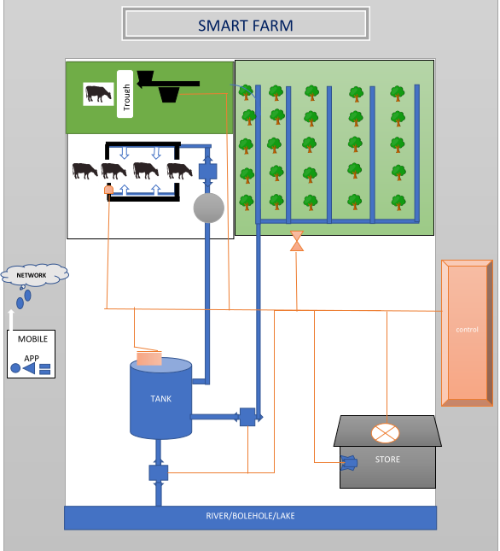

Case: A

Admin performing vendor verifications on the platform.

Case: B

Vendor uploading houses in the system

Case: C

Admin getting all orders from customers in the system and all vendors are who are awaiting verification

Case: D

Vendor getting all orders from his portfolio

Case: E

A customer performing booking in the system

## 3.2 System Architecture

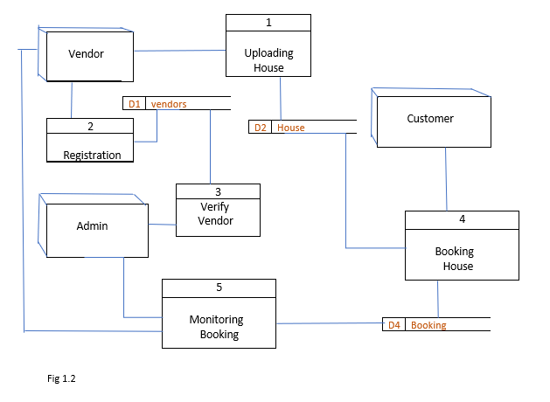

Process 1:

Vendor Uploading House in the System.

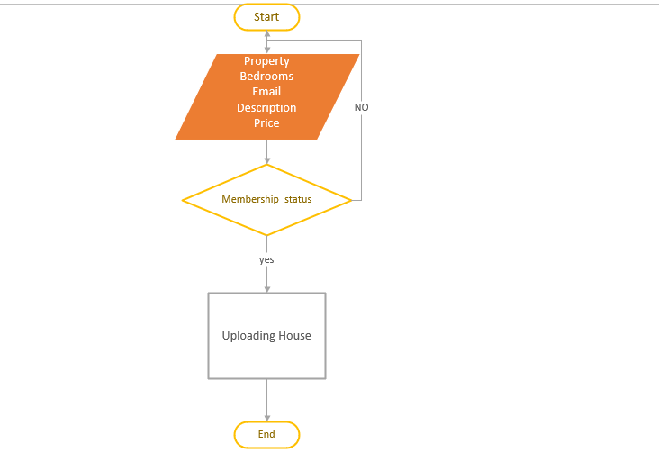fig 1.4

Process 2:

Vendor Registration in the system.

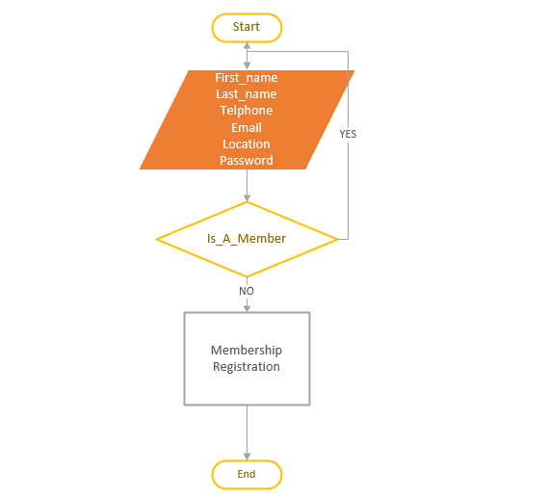

fig 1.5

Process 3:

Admin Verify The new vendor.

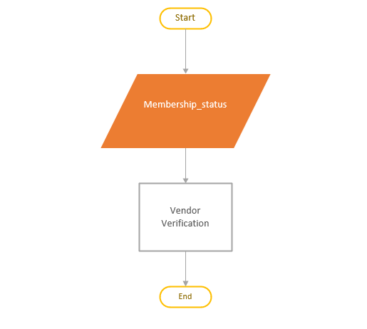

fig 1.6

Process 4:

Customers Booking House.

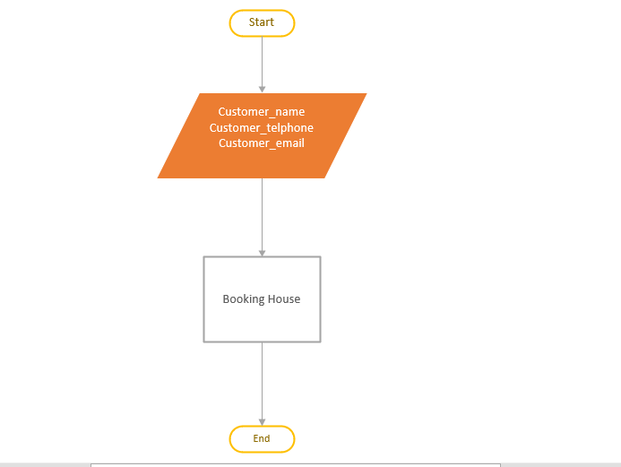

fig 1.7

Process 5:

Admin and Vendor monitoring Booked House in the system.

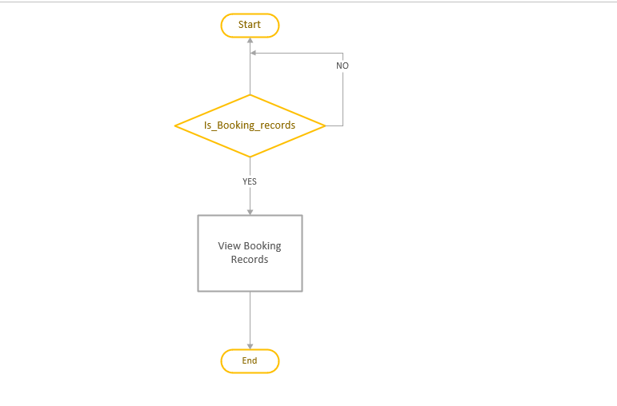

fig 1.8

## 3.2 Object Models using activity diagrams

* Vendor registration

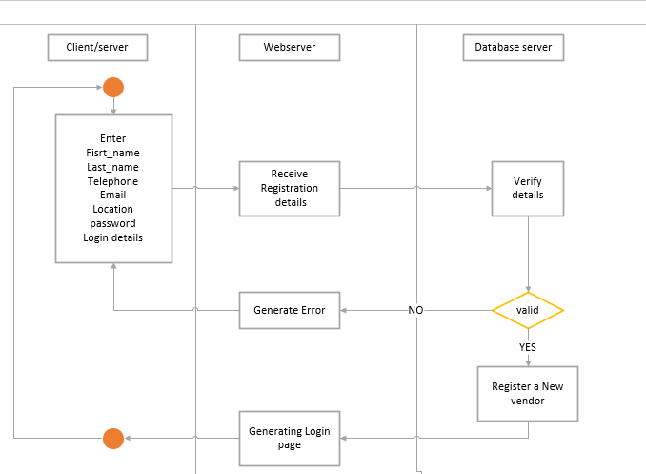

fig 1.9

### Registration Form

Form 1.1

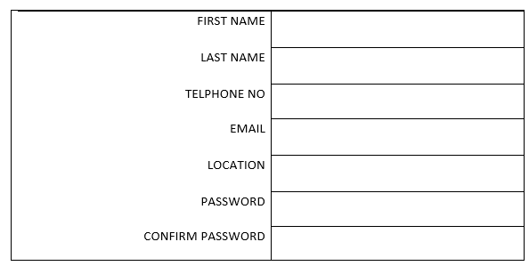

REGISTER

LOGIN

* Vendor login process

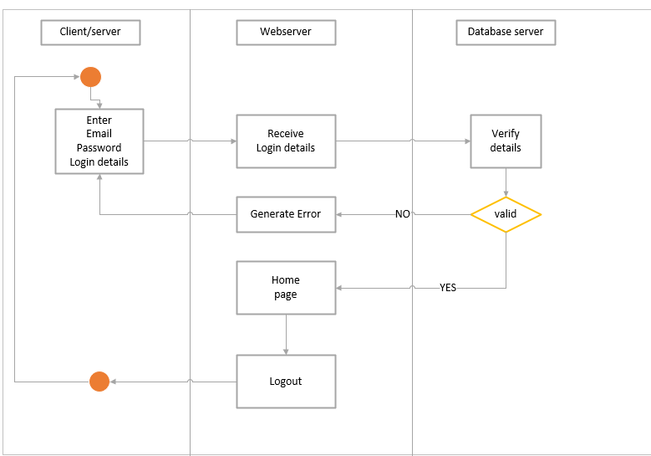

fig 1.10

### Vendor login Form

Form 1.2

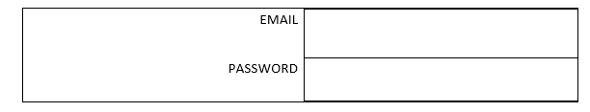

LOGIN

REGISTER

* Membership application

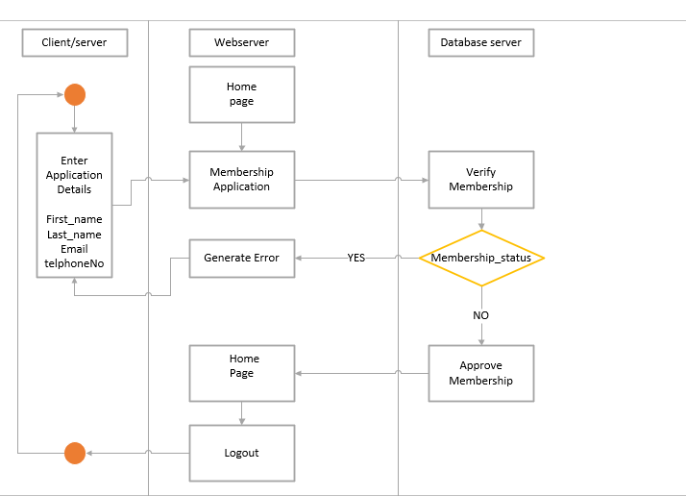

fig 1.11

### Membership Application Form

Form 1.3

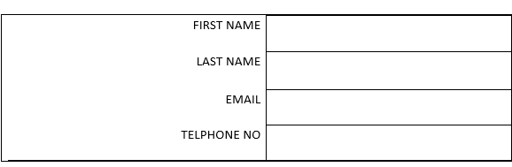

APPLY

CANCEL

* Vendor Uploading house for renting

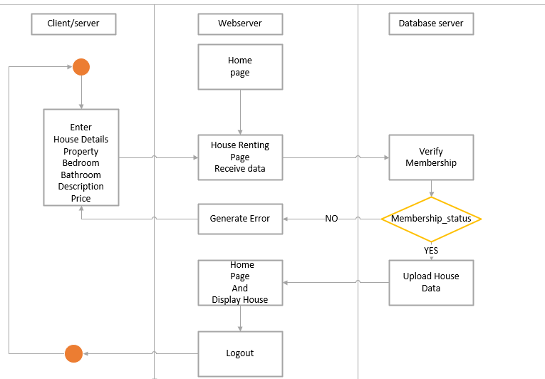

fig 1.12

### House upload Form

* Form 1.4

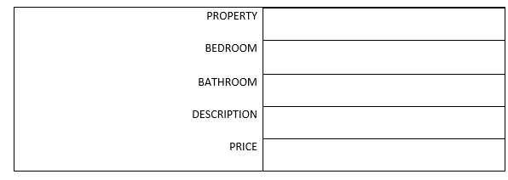

UPLOAD

CANCEL

* Customer Booking house

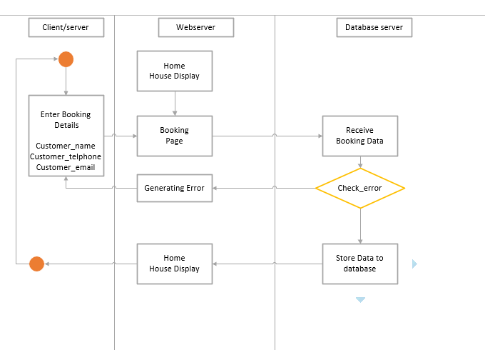

fig 1.13

### Customer Booking Form

* Form 1.5

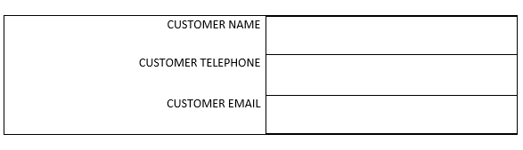

BOOK

CANCEL

* Vendor monitoring Booing records

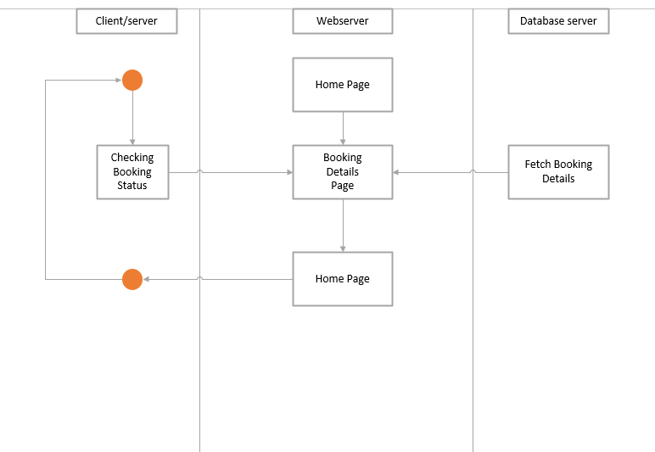

fig 1.14

* Admin login process



fig 1.15

### Admin Login Form

* Form 1.6



LOGIN

REGISTER

* Admin membership Verification

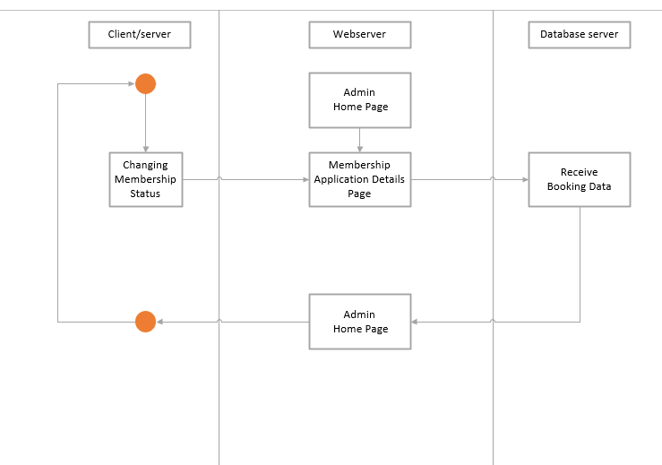

fig 1.16

* Admin membership monitoring Booking in entire system

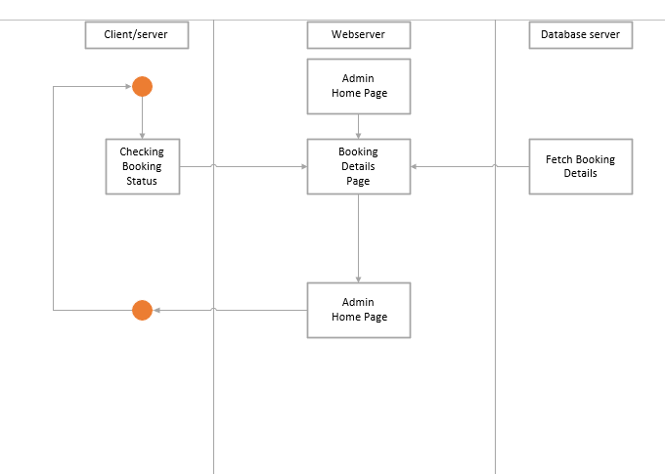

fig 1.17

## 3.3 Database design for the system.

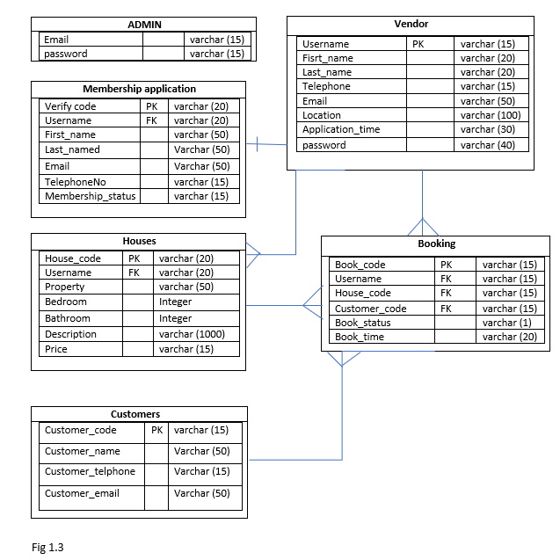

# **CHAPTER 4: CONCLUSIONS AND RECOMMENDATIONS**

## 5.1CONCLUSIONS:

In conclusion, the "Smart Farm" project represents a monumental leap forward in the realm of agriculture, offering innovative solutions to age-old farming challenges. By seamlessly integrating cutting-edge technology into farming operations, this project aims to optimize critical aspects of agriculture, including water management, irrigation, livestock care, cold storage, and feeding. The "Smart Farm" application, with its intuitive user interface and real-time monitoring capabilities, empowers farmers and administrators to efficiently manage farm resources, make data-driven decisions, and respond swiftly to changing conditions. This transformative project not only promises enhanced productivity but also paves the way for more sustainable and eco-friendly agricultural practices, aligning the farming sector with the evolving demands of the digital age and the imperative of food security.

Future Prospects:

Looking ahead, the "Smart Farm" project holds the potential to revolutionize the agriculture industry on a global scale. As it evolves and adapts to emerging technologies and practices, it will continue to offer solutions to the challenges faced by modern farmers. Moreover, the scalability and versatility of this project make it well-suited to meet the diverse needs of farming communities worldwide. By fostering a greater synergy between technology and agriculture, the "Smart Farm" project is not merely a leap forward but a leap toward a more sustainable, efficient, and resilient future for farming and food production.